National Tree Day Mandurah
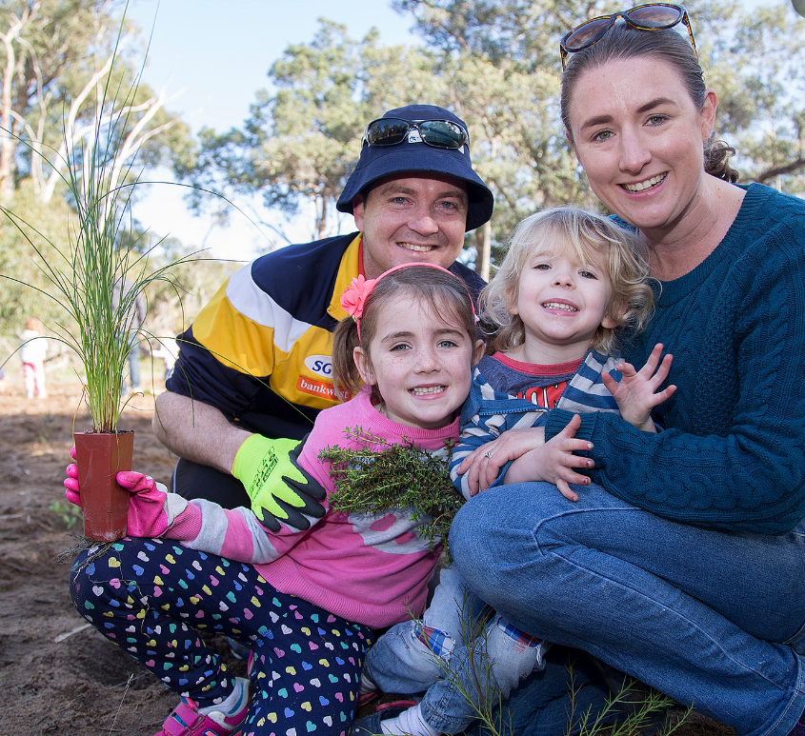
Social Story
This social story is for people attending the National Tree Day event at Marlee Reserve in Lakelands on 30 July 2023. People can read this story to themselves or have someone go through the story and pictures with them.
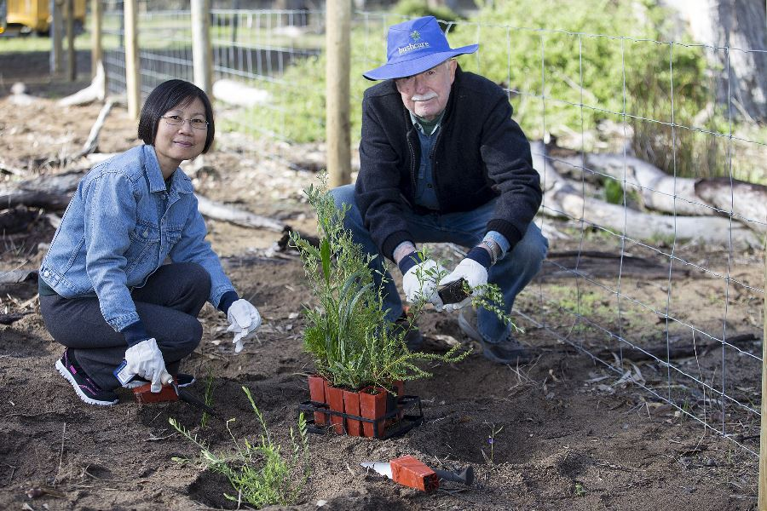
A social story is a document that uses storytelling techniques to explain new experiences and environments to people who are autistic or who have sensory sensitivities. Anyone who experiences anxiety, or is nervous when attending a place or event for the first time, may benefit from access to a social story.

National Tree Day started in 1996 and has grown into Australia's largest community tree planting and nature care event.
It's a call to action for all Australians to get their hands dirty and give back to the community.
While every day can be Tree Day, we dedicate the celebration of Schools Tree Day and National Tree Day on the last Friday and Sunday in July.

Marlee Reserve is a large space, with a mixture of open woodland with a large central swamp that isn’t fenced. A circular path travels around the central lake, with sections that are bitumen paved and other sections of uneven, crushed limestone path. I can walk to the reserve from the Lakelands train station on the Mandurah line. Transperth bus routes 577, 584, 585, and 586 also travel to the station. This walk is around 2km along a cement, crushed limestone, and sandy path.
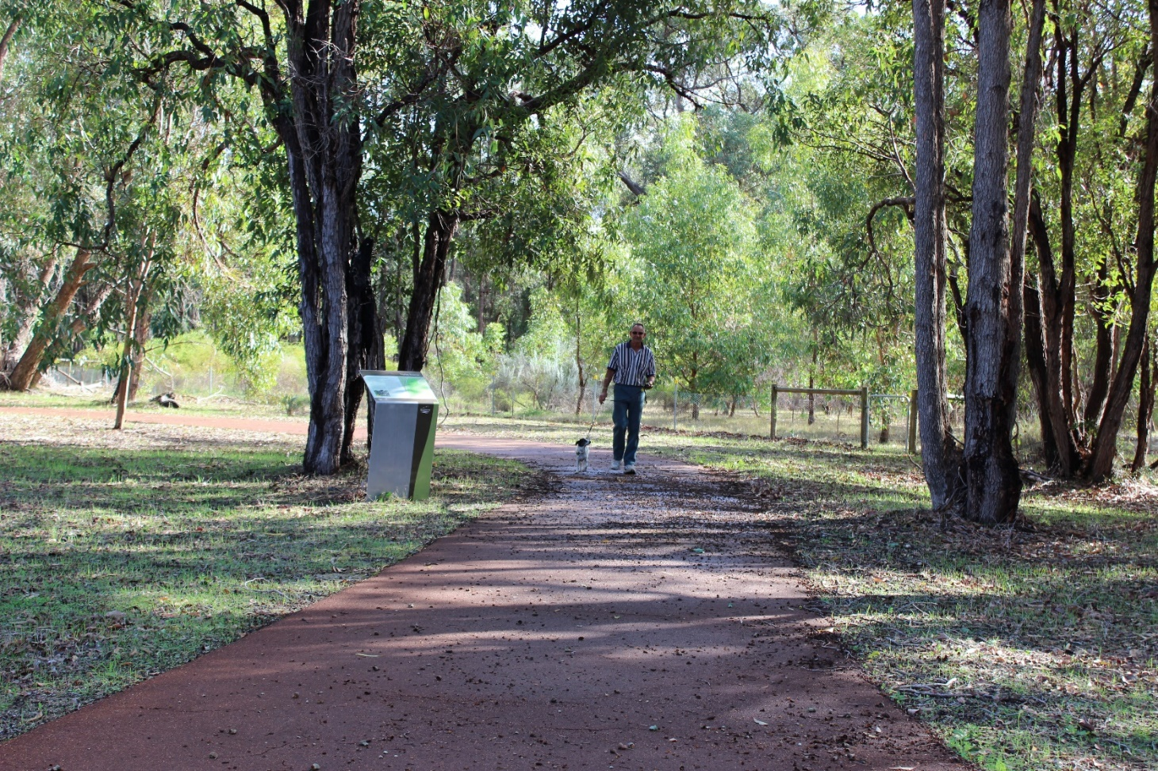
If travelling to Marlee Reserve by car, the best place to park will be the large carpark off Marlee Road. There will be some temporary ACROD parking bays allocated here. If this car park is full, I will be able to park on the roadside area. I will also be able to park at Black Swan Lake in Lakelands and walk to the event. This walk is around 1.8km along a cement, crushed limestone, and sandy path.
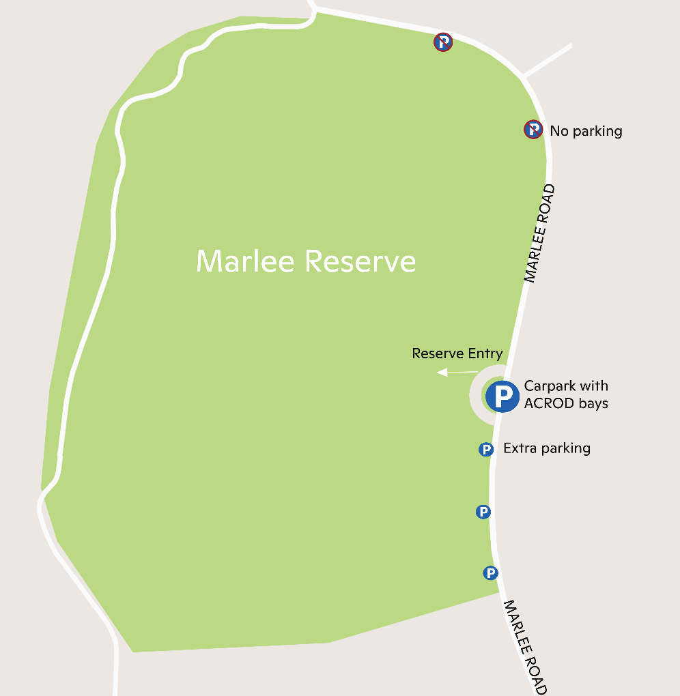
I can print the event map and bring it with me, or I can download it onto my phone or iPad. The event map can be found on the National Tree Day event webpage on the City of Mandurah Website.
The Mandurah fun train will be at the reserve to help people travel from the carpark to the main planting area. Anyone can ride the train and I may have to wait my turn in a line.
I do not have to take the Mandurah Fun Train. I can choose to walk from the carpark instead. An event volunteer will show me where to go and I will be able to follow signs to the main event. I will stay safe by only walking on the paths and looking for the train before crossing any paths.
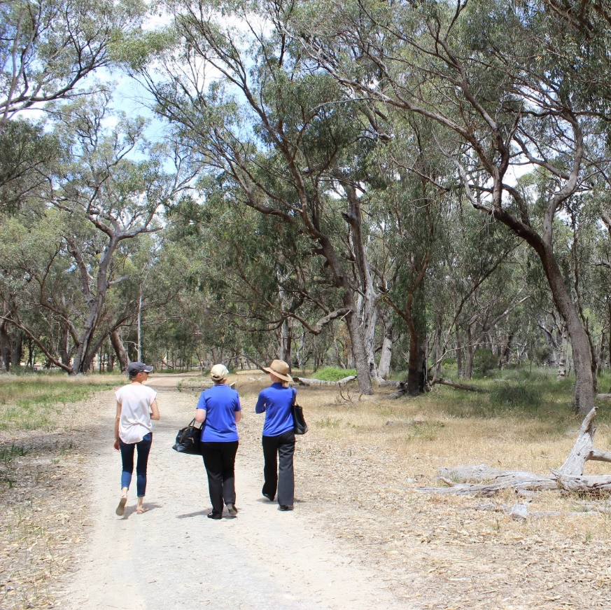
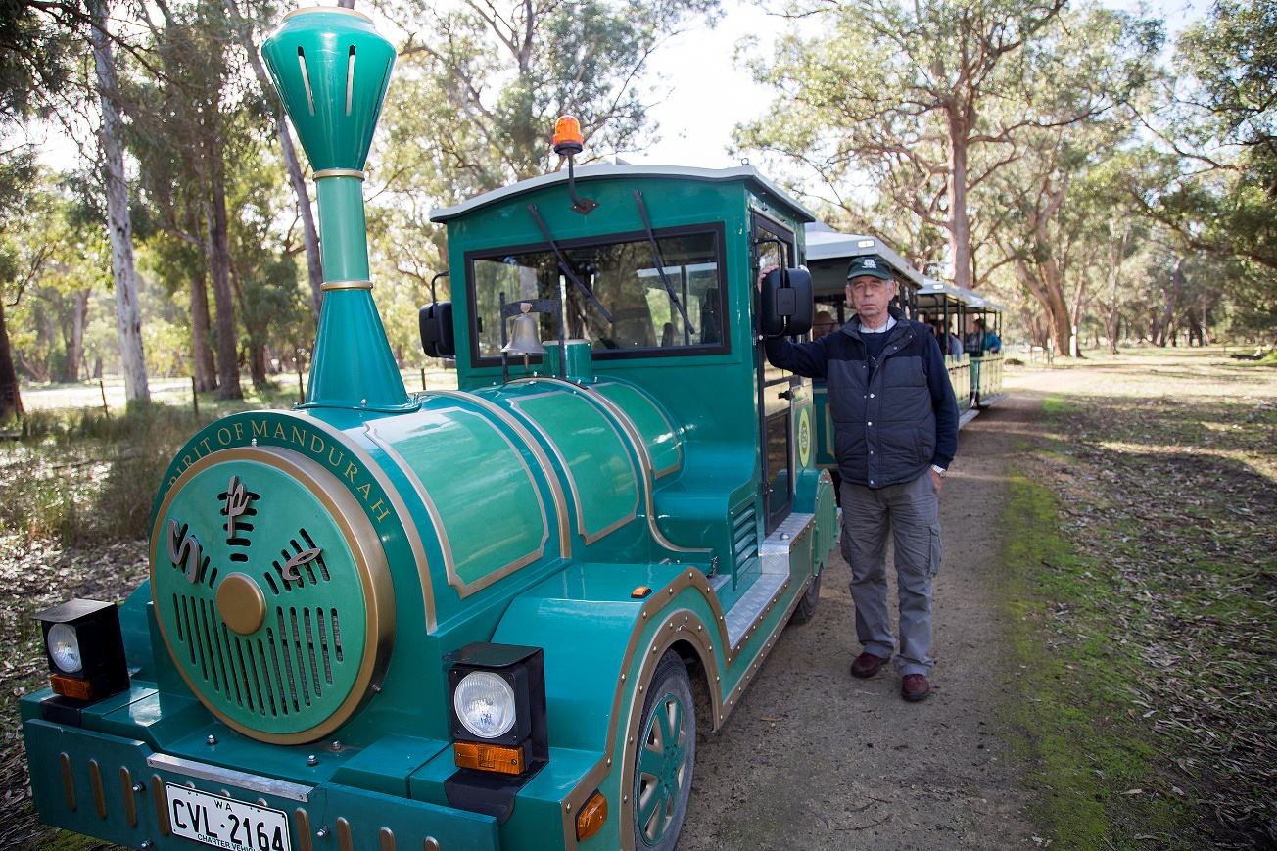

There will be an All-Terrain walking frame available for people to borrow to get around the event. The All-Terrain walking frame has large wheels to help people move across uneven surfaces. There will also be matting like what is used on the beach at the main event area to help people get around on the sandy or uneven surfaces.

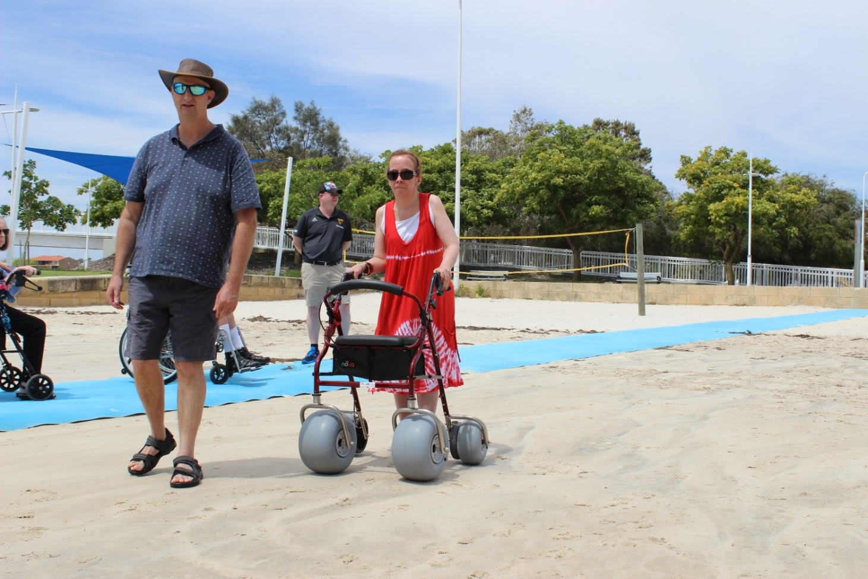

There will be different activities that I can do at the National Tree Day event including tree planting, tents with local community groups, games and art activities. Some of the activities might be busy with other people and could be noisy. I can borrow a set of noise reduction earmuffs from the Chill Out Zone to use while I am at the event.
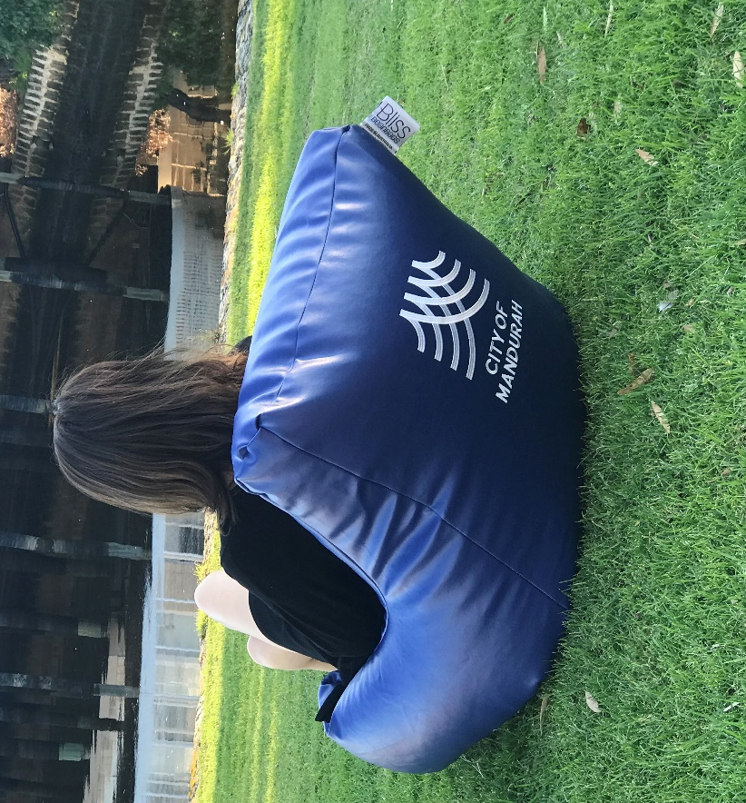
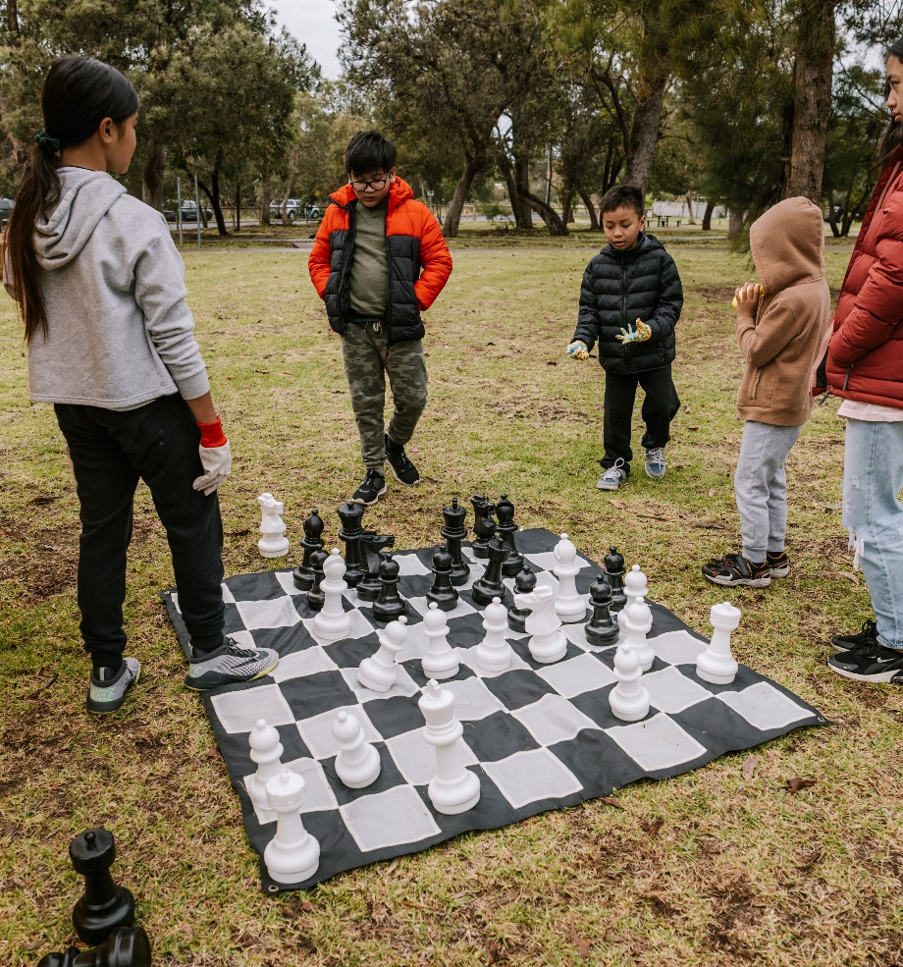
I can also visit the Chill Out Zone where there will be bean bags, fidget toys and mindful colouring in sheets which I can use to help me to feel calm.
When I am at the National Tree Day event I may like to plant a tree. I don’t have to do this. I can watch other people doing this if I prefer.
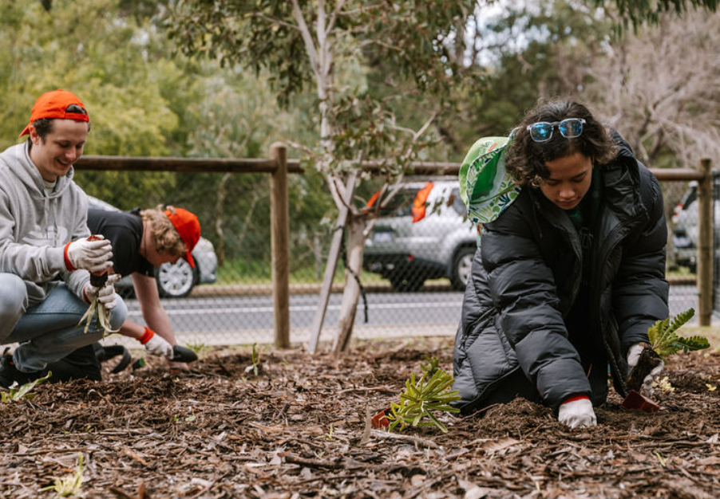

I can visit the information tents if I want to. I don’t have to do this. The people at the information tents enjoy talking with people about the information in their tent.
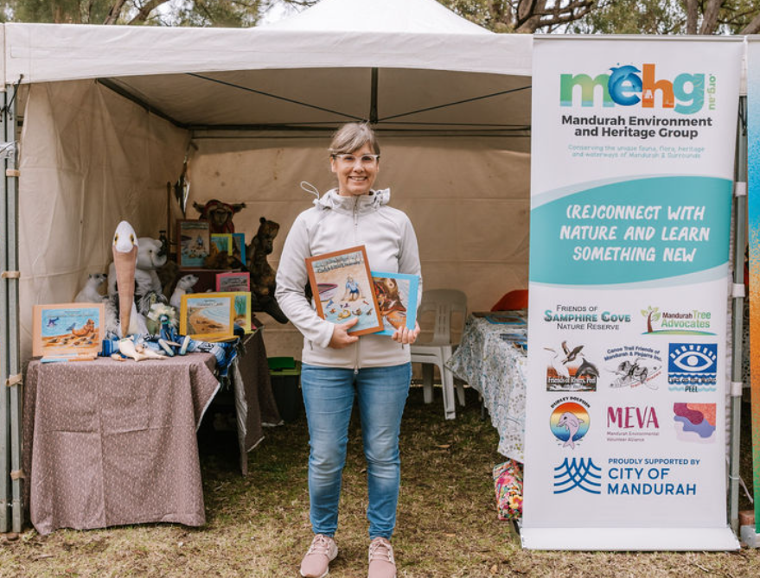
If I, or my family, need help at the National Tree Day event we can ask an Event Volunteer. Event Volunteers will be wearing National Tree Day shirts or yellow vests, or we can go to the Information table.
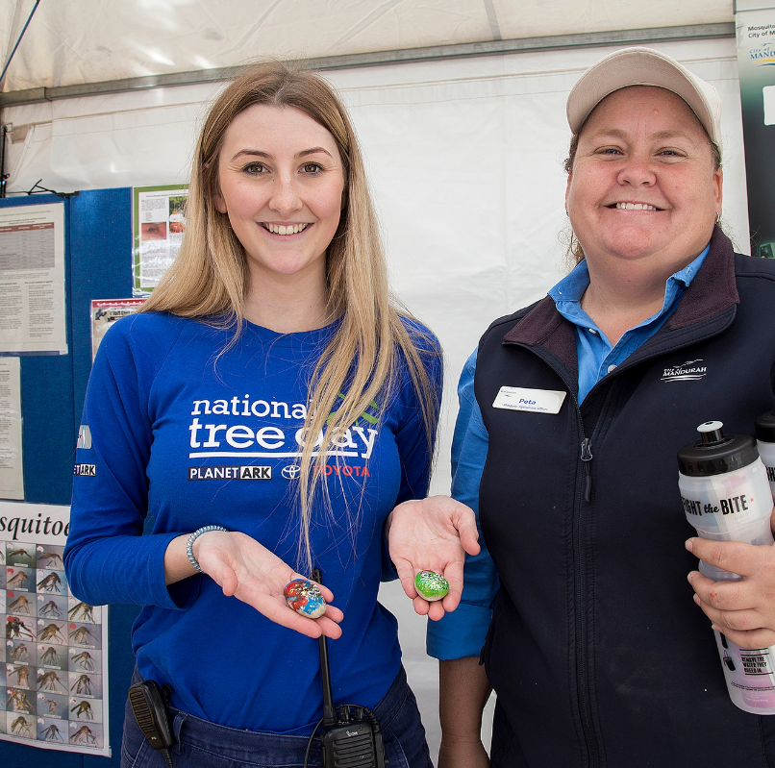
There will be portable toilets at the event including a wheelchair accessible toilet.
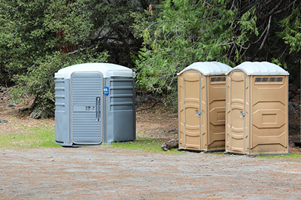

There will be a free BBQ at the event. There will be sausages, vegetarian options, onion and sauces. The volunteers at the BBQ will ask me about what I want to eat.
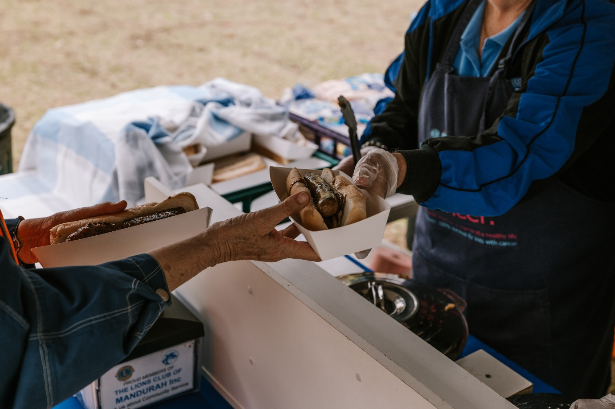

People have a good time at Tree Planting events and I hope to also have a good time.
